Models (“User” refers to the “Author” table in DB diagram):

|  |  |
| --- | --- |
| Story | Model for stories. |
| StoryFormViewModel | Show story information in a form. |
| Category | Manage categories that stories can belong to. |
| User | User Model. |
| UserFormViewModel | Show user’s information in a form. |
| TagModel | Manage tags for each story. (including user defined ones). |
| TagFormViewModel | Show tags of a story in a form. |
| Comment | Manage comments for each story. |
| CommentFormViewModel | Show user comments for each story in a form. |

Views:

|  |  |
| --- | --- |
| Story/Details | Show information (including tags and some comments) for a story. |
| Story/Edit | Edit content/other attributes for a story. |
| Story/List | Show all stories filtered by author, category or other attributes. |
| User/Profile | Show user profile. |
| User/EditProfile | Edit user profile. |
| Comment/List | Show all comments for a story. |

Here’s the database diagram:

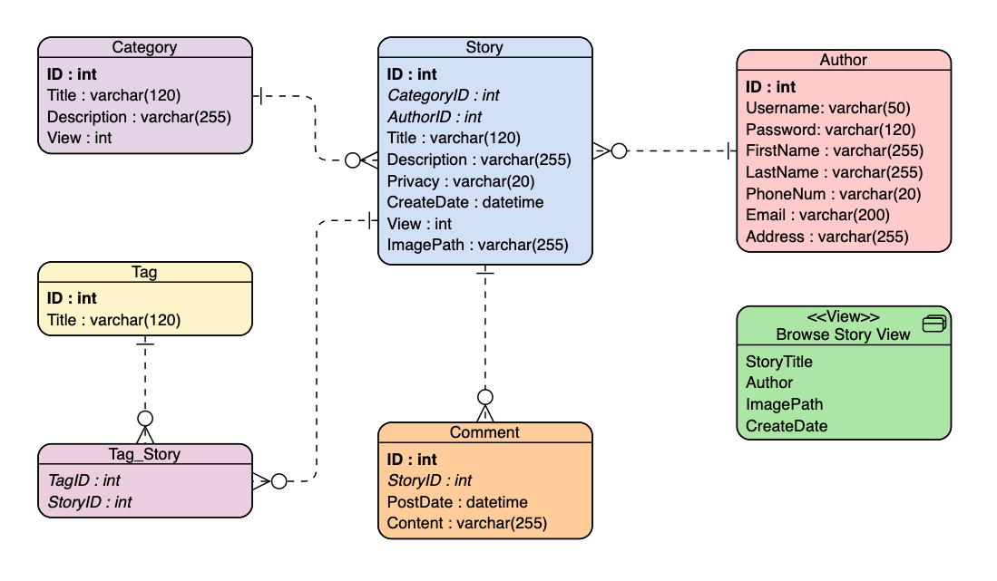

Draft of Views

